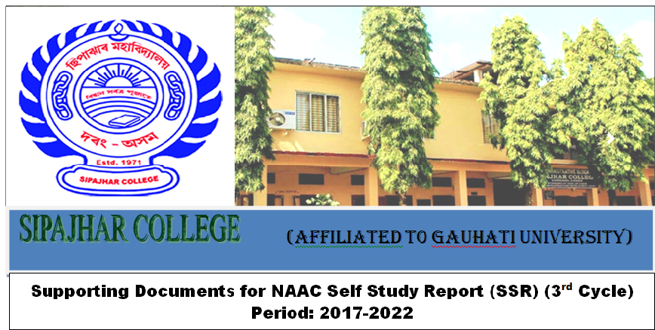
Criteria-7 | Key Indicator 7.1
Institutional Values and Best Practices | Institutional Values and Social Responsibilities
Metric No : 7.1.1 | Measures initiated by the Institution for the promotion of gender equity and Institutional initiatives to celebrate / organize national and international commemorative days, events and festivals during the last five years

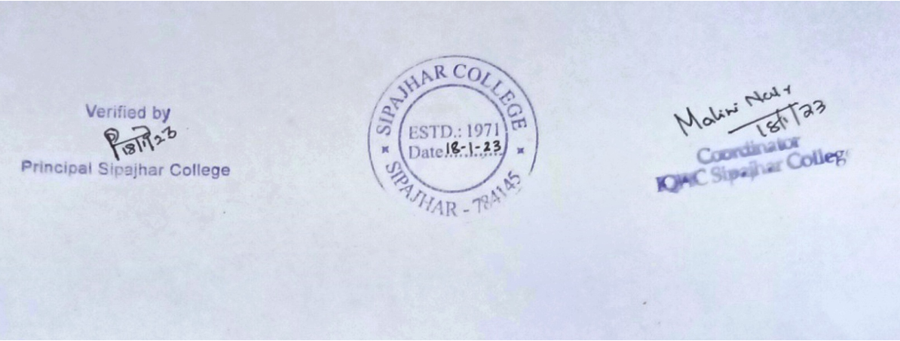

List of various National and International Commemorative days celebrated/observed by Sipajhar College-2022
Commemorative day | Date
International Women’s Day | 08/03/2022
World No Tobacco Day | 31/05/2022
World Health Day | 07/04/2022
World Water Day | 22/03/2022
World Forestry Day | 22/03/2022
World Poetry Day | 21/03/2022
World Wildlife Day | 03/03/2022
National Science Day | 28/02/2022
International Mother Language Day | 21/02/2022
International Yoga Day | 21/06/2022
Rongali Bihu | 19/04/2022
Republic Day | 26/01/2022
Death Anniversary of Lal Bahadur Sastri | 11/01/2022
Christmas | 23/12/2022
International Philosophy Day | 17/11/2022
International Human Rights Day | 10/12/2022
World Environment Day | 04/06/2022
Draw a Bird Day | 08/04/2022
National Mathematics Day | 22/12/2022
International Day of Mathematics | 14/03/2022
Independence Day | 15/08/2022
National Education Day | 11/11/2022
World AIDS Day | 01/12/2022
Constitution Day | 26/11/2022
400thBirth Anniversary of LachitBarphukan | 22/11/2022
National Unity Day | 31/10/2022
World Mental Health Day | 14/10/2022
World Tourism Day | 27/09/2022
96th Birth Anniversary of BharatratnaDr. Bhupen Hazarika | 08.09.2022
Teachers’ Day | 05/09/2022
Vishwakarma Puja | 17/09/2022
National Librarians’ Day | 12/08/2022
Birth Anniversary of MahapurushMadhabdeva | 17/05/2022
World Book & Copyright Day | 23/04/2022
World Earth Day | 22/04/2022
World Fungus Day | 02/10/2022
World Ozone Day | 16/09/2022

List of various National and International Commemorative days celebrated/observed by Sipajhar College-2021
Commemorative day | Date
World Philosophy Day | 18/11/2021
International Yoga Day | 21/06/2021
Voter Awareness Programme | 16/03/2021
Republic Day | 26/11/2021
National Science Day | 27/02/2021
International Women’s Day | 08/03/2021
World Environment Day | 05/06/2021
National Voters’ Day | 25/01/2021
National Mathematics Day | 22/12/2021
National Pollution Prevention Day | 02/12/2021
Independence Day | 15/08/2021
World Cerebral Palsy Day | 06/10/2021
World Ozone Day | 16/09/2021
International No Diet Day | 06/05/2021
Saraswati Puja | 16/02/2021

List of various National and International Commemorative days celebrated/observed by Sipajhar College-2020
Commemorative day | Date
Independence Day | 15/08/2020
National Mathematics Day | 22/12/2020
Republic Day | 26/01/2020
International Women’s Day | 08/03/2020
World Environment Day | 05/06/2020
Gandhi Jayanti | 02/10/2020
National Science Day | 28/02/2020
World Cancer Day | 04/02/2020

List of various National and International Commemorative days celebrated/observed by Sipajhar College-2019
Commemorative day | Date
International Women’s Day | 08/03/2019
Voter Awareness Programme | 15/03/2019
International Yoga Day | 21/06/2019
Independence Day | 15/08/2019
Republic Day | 26/01/2019
Teachers’ Day | 05/09/2019

List of various National and International Commemorative days celebrated/observed by Sipajhar College-2018
Commemorative day | Date
International Women’s Day | 08/03/2018
World Environment Day | 05/06/2018
International Yoga Day | 21/06/2018
Independence Day | 15/08/2018
Republic Day | 26/01/2018

List of various National and International Commemorative days celebrated/observed by Sipajhar College-2017
Commemorative day | Date
World Environment Day | 05/06/2017
Republic Day | 26/01/2017
Independence Day | 15/08/2017
International Yoga Day | 21/06/2017

