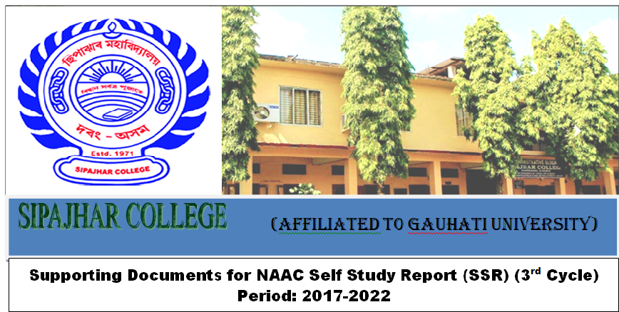
Criteria-7 | Key Indicator 7.1
Institutional Values and Best Practices | Institutional Values and Social Responsibilities
Metric No : 7.1.3 | Quality audits on environment and energy regularly undertaken by the Institution.  The institutional environment and energy initiatives are confirmed through the following  1. Green audit/Environment audit  2. Energy audit  3. Clean and green campus initiatives  4. Beyond the campus environmental promotion activities
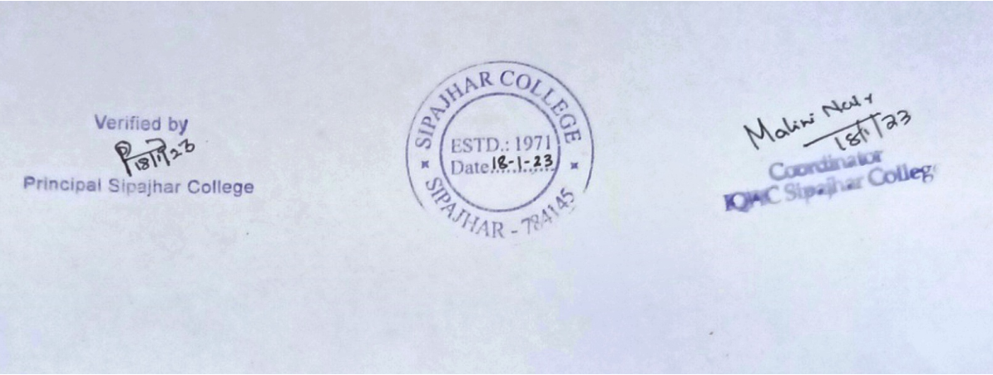
1. Green Audit/Environment Audit
Sl. No. | Particular required | Status/supporting document
I(A) | Green Audit/Environmental Audit- 2021 | http://sipajharcollege.ac.in/achievement.php
I(B) | Green Audit/Environmental Audit- 2023 (Review on recommendations and steps taken) | http://sipajharcollege.ac.in/upload/achievements/1676354536.JPG  http://sipajharcollege.ac.in/upload/achievements/1676354612.JPG

2. Energy Audit
Sl. No. | Particular required | Status/supporting document
II(A) | Energy Audit-2021 | http://sipajharcollege.ac.in/achievement.php
II(B) | Energy Audit-2023 (Review on recommendations and steps taken) | http://sipajharcollege.ac.in/upload/achievements/1676354558.JPG

3. Clean and Green Campus Initiatives
Sipajhar College at a Glance
Sipajhar College has adopted all the measures at its best for energy conservation, waste management, water conservation, green campus initiatives and to create a barrier friendly inclusive environment to all of the college without discrimination, exploitation and exclusion of differently able individuals from all spheres of work and education. The college has amaster plan of land useand accordingly plantation, construction and renovations have been going on in the campus. To monitor and control all those purposes, the college has adopted certain code of conduct and producedd a code of conduct committee too. The former is clearly displayed at the college entry and website. Sipajhar college has been always promoting an anti tobacco and plastic free environment and there are strict rules in these concerns as mentioned in the code of conduct.
Alternate energy source and steps taken for energy conservation
Sipajhar college has taken many initiatives to reduce energy conservation. College has always preferred the use electrical equipments, bulbs and devices which are energy-efficient. Only LED bulbs and tubes are installed in all classrooms, office, library and other parts of the college. All equipments such as computer, AC, refrigerator, etc. are low power consuming. Clear display of instructions to turn off devices when not in use are placed. A monitoring committee comprising of teachers and students routinely check electrical equipment. The committee creates awareness among all through different activities and awareness campaigns. To reduce fossil fuel consumption, as a power back up, college has installed two solar panels and sensor based lights. Another proposal for installation of solar panel on the rooftop of the women’s hostel has been submitted to ICICI foundation, Darrang Division. Power consumption is reduced by using water from water bodies, harvested rain water; tube well which are available without use of power. Installation of water overflow alarm system in water reservoirs has contributed a lot in reducing both water over flow and power consumption. All college individuals are encouraged to use public transport and/or us of bicycle by observing fuel free day, earth day, etc.

Waste Management
College follows the principle of ‘5 R’s’ i.e. Refuse, Reduce, Reuse, Repurpose and Recycle. The college follows proper scientific procedure for segregation and management of waste and their treatment and disposal. Chemical, hazardous and e-waste are segregated at the origin and separately labeled containers are used for storing these. The college has collaboration with Dal-Thom’s Scientific- the partner organization- regularly collects different chemical waste generated in the science laboratories. Other waste are also classified and separated as biodegradable, non-biodegradable, paper, e-waste, etc. for further treatment. Dustbins of designated colors are placed in the college. Replacement/Sale of e-waste such as battery, UPS, etc. with new items is done on regular basis with the suppliers. The remaining amount of e-waste is collected by the partner organization with which the college has signed MoU. Vending machine and incinerators are installed in girl’s hostel, common room, etc., to maintain a good health and hygiene. Display on waste management instructions/alerts in conspicuous/relevant areas on the campus, promote a paperless work healthy environment. Apart from reusing biodegradable waste in green house, mushroom culture and vermin-composting unit, involvement of students in these has deeply rooted the responsibility and skills for sustainability. Regular orientation and hands on training on waste management among students and staff of the college has created a beautiful clean and healthy ambience in the campus. College has also started a certificate course on plastic waste management for greater benefit of the society.

Water Conservation

The college has a proper drainage system to channel water to the water bodies and to community drainage system. The campus has been declared as plastic free (single use) and proper scientific procedures are followed for disposal of other waste too, to ensure that there is no blockage of drainage system and that the natural run of water is not hampered. There are two water bodies inside the campus which are used for pisciculture from which certain amount of yearly revenue is generated. At the same time both the water bodies are well maintained too. Water usage and related maintenance of the college is monitored and regulated by a water monitoring committee. College has installed two rain water harvesting, one with provisions for recharging ground water. Used water is recycled in gardening- watering plants, trees, etc. Besides the use of water from bore well and tube well, water from ponds and harvested rain water are always encouraged. Installation of water overflow alarm in all water tanks restricts overflow and spillage of water.

Green Campus Initiatives

Except for the built up area, most of the college campus is under green cover. Frequent and well planned plantation programs and their protections is a common practice of the college. Database on all the flora &fauna in the campus has been prepared by students under the supervision of assigned faculty and experts in the field. More activities such as orientation on vermi-composting, mushroom culture and reuse of biodegradable waste, installation of hydroponic set up, etc. are also conducted on regular basis. And on special days of significance such as world environment day, earth day these are further extended to the people of nearby locality and adopted village. Water supply to all plants is made more accessible by improving the water supply provisions, by installing rain water harvesting units at different locations of the college. Raising environmental awareness on climate change impact tracking and steps to lessen environmental carbon footprints and emissions are part of good practices of the college.
The practice of using a green diary by students has been a best practice of the college which did not merely require students to plant a sapling but develops concern in them about the importance and necessity of a healthy environment. Environmental-related projects and experiments in the curriculum as part of the educational system is a routine practice. Classification and naming of all trees, installation of bird house at different locations enhanced the aesthetic look and inner beauty of whole campus. Cleanliness drive by students and volunteers of NSS and Scouts and Guides are frequently carried out in the campus and outside too.
Decentralized duty and responsibility of activities have been initiated for proper functioning of all such activities to make a clean green and healthy environment. The college has formed a number of monitoring and management committees such as water monitoring, committee for greenery, carbon foot print, comprises of a teacher in-charge, staff of the college and student members.
Periodic green, energy and water audits are done to identify the issues which need to be looked into to create a pollution free greener campus. Such audits are conducted by internal experts assigned by Principal and IQAC of the college and external recognized bodies.

Policies and additional information regarding above facilities available in Sipajhar College
Sl. No. | Particular | Supporting Files/Web Links
1 | Installation of LED bulb and tubes | http://sipajharcollege.ac.in/upload/green_initiative/1676363979.pdf  http://sipajharcollege.ac.in/upload/green_initiative/1676443999.pdf
2 | Low power consuming fan and electrical equipments | http://sipajharcollege.ac.in/upload/green_initiative/1676443999.pdf
3 | Solar energy back up and initiative to install more | http://sipajharcollege.ac.in/upload/green_initiative/1676363979.pdf
4 | Display and regular monitoring on turn off of all electrical equipments and devices when not in use | http://sipajharcollege.ac.in/upload/green_initiative/1676363979.pdf
5 | Celebration of fuel free days by all college individuals. | http://sipajharcollege.ac.in/upload/green_initiative/1676363979.pdf
6 | Installation of sensor based bulbs | http://sipajharcollege.ac.in/green_initiative.php
7 | Proper drainage system | http://sipajharcollege.ac.in/upload/green_initiative/1676442255.pdf
8 | Use of tube well/water bodies as water source | http://sipajharcollege.ac.in/upload/green_initiative/1676442255.pdf
9 | Stored rain water and its use in gardening practices, hostel and in laboratories | http://sipajharcollege.ac.in/upload/green_initiative/1676442255.pdf  http://sipajharcollege.ac.in/upload/green_initiative/1676443999.pdf
10 | Use of water overflow alarm on all water reservoirs | http://sipajharcollege.ac.in/upload/green_initiative/1676443999.pdf
11 | Awareness and display on Turn off water tap when not in use | http://sipajharcollege.ac.in/upload/green_initiative/1676443999.pdf
12 | Routine monitoring of water leakage and their fixation by Water Management committee | http://sipajharcollege.ac.in/upload/achievements/1676451474.pdf (Refer to pg no 27)
13 | Pisciculture & maintaining water bodies inside campus | http://sipajharcollege.ac.in/upload/green_initiative/1676442255.pdf
14 | Students Project on Water quality parameters as a part of curricular activity | http://sipajharcollege.ac.in/upload/green_initiative/1676442255.pdf
15 | Segregation of waste as biodegradable/non- biodegradable, paper others | http://sipajharcollege.ac.in/upload/green_initiative/1676442164.pdf  http://sipajharcollege.ac.in/upload/policy/1676102057.pdf
16 | Segregation and separate storing of laboratory waste as chlorinated, hazardous, carcinogenic, etc. | http://sipajharcollege.ac.in/upload/green_initiative/1676442164.pdf  http://sipajharcollege.ac.in/upload/policy/1676102057.pdf
17 | Regular activities such as orientation to students and employees of the college on waste management | http://sipajharcollege.ac.in/upload/green_initiative/1676442164.pdf  http://sipajharcollege.ac.in/upload/policy/1676102057.pdf
18 | Participation of partner organization in all above activities who has signed MoU with the college | http://sipajharcollege.ac.in/upload/green_initiative/1676442164.pdf  http://sipajharcollege.ac.in/upload/policy/1676102057.pdf  http://sipajharcollege.ac.in/upload/iqac_file/1676444653.pdf
19 | Use of Biodegradable waste in Vermicompost unit and for feeding cattle | http://sipajharcollege.ac.in/upload/green_initiative/1676442164.pdf  http://sipajharcollege.ac.in/upload/green_initiative/1676443999.pdf
20 | Periodic Green, energy, water audit by recognized body and up gradation of all facilities as per recommendations | http://sipajharcollege.ac.in/achievement.php
21 | Land use map and Landscaping | http://sipajharcollege.ac.in/upload/green_initiative/1676454618.pdf
22 | Record on all Flora and Fauna Species prepared by students under the supervision of assigned faculty members expert in the field. | http://sipajharcollege.ac.in/upload/green_initiative/1676357550.pdf  http://sipajharcollege.ac.in/upload/green_initiative/1676356200.pdf
23 | Name plate on all plant species | http://sipajharcollege.ac.in/upload/green_initiative/1676442133.pdf
24 | Flower garden and vegetable garden | http://sipajharcollege.ac.in/upload/green_initiative/1676442133.pdf
25 | Installation of Green House/mushroom and its practices | http://sipajharcollege.ac.in/upload/green_initiative/1676442133.pdf  http://sipajharcollege.ac.in/upload/green_initiative/1676443999.pdf
26 | Plastic and tobacco ban campaign and code of conduct | http://sipajharcollege.ac.in/code_conduct.php
27 | Celebration of Special Days of significance | http://sipajharcollege.ac.in/upload/iqac2_file/1674884311.pdf

Beyond the Campus Environmental Promotion Activities
Sl. No. | Event | Activity | Place | Supporting Documents | Year
1 | World Environment Day | Plantation outside campus | College Chowk | Activity 5  http://sipajharcollege.ac.in/upload/iqac2_file/1674884311.pdf | 05/06/2017
2 | World Environment Day | Plantation outside campus | Adopted Village | Activity 4  http://sipajharcollege.ac.in/upload/iqac2_file/1674884311.pdf | 05/06/2018
3 | Awareness on Cleanliness drive by NSS | Students Participation in cleanliness drive | Near local police station | Activity 17 of NSS unit  http://sipajharcollege.ac.in/upload/iqac2_file/1675844455.pdf | 22/10/2018
4 | Anti Drug and Swachta Awareness Camp by NSS | Awareness programme | Maroi Bijulibari | Activity 5 of NSS unit  http://sipajharcollege.ac.in/upload/iqac2_file/1675844455.pdf | 29/01/2019 to 30/01/2019
5 | Maintenance of green diary | One student take responsibility to plant, protect a plant and keeps records on its growth | All across Darrang District | http://sipajharcollege.ac.in/best_practice.php | 2019 onward
6 | National Wildlife week | Orientation on preparing poster (Sustaining all life on earth) | State level | http://sipajharcollege.ac.in/upload/dept_activities/1643707893.pdf | 20/10/2020
7 | National Wildlife week | Poster Making Competition | State level | http://sipajharcollege.ac.in/upload/dept_activities/1643707893.pdf | 09/11/2020
8 | Sanitizer preparation during covid-19 pandemic | Distribution among staff and villagers | Nearby locality and adopted village | http://sipajharcollege.ac.in/upload/dept_activities/1643705545.pdf | 27/03/2020
9 | Workshop on Management and restoration of Bengnoi River |  | College premise and Bengnoi site | http://sipajharcollege.ac.in/upload/dept_activities/1649318886.pdf | 21/12/2020
10 | Sanskar: Manuhe Manuhor Babe | Talk on Health and Hygiene | Nehru Smriti Balika Bidyalaya | http://sipajharcollege.ac.in/upload/dept_activities/1675842878.pdf | 07/11/2020 onward
11 | World Environment Day | Massive plantation Drive Competition/Online Quiz Competition | Darrang District | http://sipajharcollege.ac.in/upload/dept_activities/1643874288.pdf | 05/06/2021 onward
12 | Students survey on health disorder in locality | Survey on different water borne health disorders | Different Villages of Sipajhar | http://sipajharcollege.ac.in/upload/dept_activities/1646982878.pdf | 01/03/2021 onward
13 | Awareness and water sample collection from Bahmolla Village, an arsenic prone area | Arsenic Testing | Bahmolla Village | http://sipajharcollege.ac.in/upload/dept_activities/1646982878.pdf | 01/03/2021 onward
14 | Outreach Activity by Environment and Climate Cell | B.Sc. students talk on environment and climate | Sipajhar Academy | http://sipajharcollege.ac.in/upload/dept_activities/1643866847.pdf | 03/03/2021
15 | Students visit to Manas National Park | Field Trip | Manas National Park | http://sipajharcollege.ac.in/upload/dept_activities/1642252545.pdf | 24/12/2021
16 | Environmental Awareness | Awareness and plantation drive | Maroi Bijulibari | http://sipajharcollege.ac.in/upload/dept_activities/1666676011.pdf | 23/12/2021
17 | World Environment Day | Awareness and Installation of Bird House | Maroi Bijulibari | http://sipajharcollege.ac.in/upload/dept_activities/1667381497.pdf | 04/06/2022
18 | Outreach Activity by Environment & Climate Cell | Demonstration on lab equipments available in the school science Laboratory and applications in studying environmental pollution | Gandhi Smriti HS School, Hazarikapara | http://sipajharcollege.ac.in/upload/dept_activities/1675861351.pdf | 05/05/2022
19 | Field Trip | Study the present scenario of Bodiahisa wetland | Bodiahisa Wetland | http://sipajharcollege.ac.in/upload/dept_activities/1667293088.pdf | 07/03/2022
20 | Field Trip | To make students understand and realize importance nature and natural resources | Kaziranga National Park | http://sipajharcollege.ac.in/upload/dept_activities/1669881362.pdf | 26/11/2022

